1’s Complement Subtraction Explained with Examples

1’s complement subtraction is a method to subtract two binary numbers. This method allows subtraction of two binary numbers by addition. The 1’s complement of a binary number can be obtained by replacing all 0 to 1 and all 1 to 0. This article discusses steps involved in 1’s complement subtraction of a smaller number from a larger number & the steps for subtracting a smaller number from a larger number with example.

Steps for 1’s Complement Subtraction:

Subtraction of Smaller Number from Larger Number:

The steps for 1’s complement subtraction of a smaller number from a larger binary number are as follows:
Step-1: Determine the 1’s complement of the smaller number.
Step-2: Add this to the larger number.
Step-3: Remove the carry and add it to the result. This carry is called end-around-carry.

Following examples illustrates the septs involved in 1’s complement subtraction of a smaller number from larger number.
Example-1:
Subtract (1010)₂ from (1111)₂ using 1’s complement method.
Step-1: Find the 1’s complement of 1010. It will be found by replacing all 0 to 1 and all 1 to 0. In this way, the required 1’s complement will be 0101.
Step-2: In this step, we need to add the vale calculated in step-1 to 1111. This is shown below.
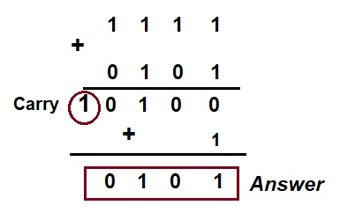
For your reference, addition of binary digits 1 + 1 = 10. Also, note that carry 1 has been added to the addition to get the subtraction of the binary numbers. Thus, the subtraction is done by actually adding two binary numbers.

Subtraction of Larger Number from Smaller Number:
The steps involved in 1’s complement subtraction of a larger number from a smaller number are as follows:
Step-1: Determine the 1’s complement of the larger number.
Step-2: Add this to the smaller number.
Step-3: The answer is the 1’s complement of the true result and opposite in sign. There is no carry.
Following examples illustrates the application of above mentioned septs for subtraction of a larger number from smaller number.
Example:
Subtract (1010)₂ from (1000)₂ using 1’s complement method.
The 1’s complement of (1010)₂ is (0101)₂. Now, we will add this with the smaller number and finally take 1’s complement of the result to get the answer. This is shown below.
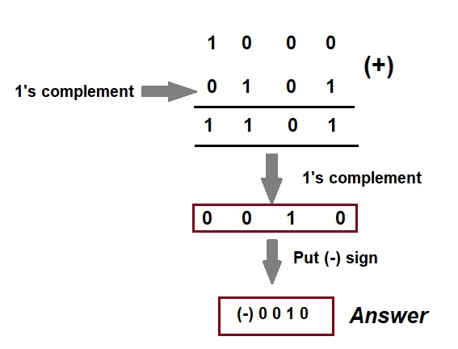
Mind that, no carry has been obtained while subtracting a larger number from a smaller number. Further, a minus sign has been put.
Method: 1's complement subtraction Steps:
1. At first, find 1's complement of the B(subtrahend).
2. Then add it to the A(minuend).
3. If the final carryover of the sum is 1, then it is dropped and 1 is added to the result.
4. If there is no carry over, then 1's complement of the sum is the final result and it is negative.

1. Find Subtraction of 110 and 101 using 1's complement method
Here A = 111, B = 101.
Find A - B = ? using 1's complement
First find 1's complement of B = 101
Note : 1's complement of a number is obtained by subtracting all bits from 111.
1's complement of 101 is
 | 1 | 1 | 1
- | 1 | 0 | 1
 | 0 | 1 | 0
Now Add this 1's complement of B to A
1 | 1
 | 1 | 1 | 0
+ | 0 | 1 | 0
1 | 0 | 0 | 0
Hints : (Move mouse over the steps for detail calculation highlight)
The left most bit of the result is called carry and add it to the rest part of the result 000.
 | 0 | 0 | 0
+ |  |  | 1
 | 0 | 0 | 1
So answer is 001

2. Find Subtraction of 10110 and 11101 using 1's complement method
Here A = 10110, B = 11101.
Find A - B = ? using 1's complement
First find 1's complement of B = 11101
Note : 1's complement of a number is obtained by subtracting all bits from 11111.
1's complement of 11101 is
 | 1 | 1 | 1 | 1 | 1
- | 1 | 1 | 1 | 0 | 1
 | 0 | 0 | 0 | 1 | 0
Now Add this 1's complement of B to A
 |  | 1 | 1
 | 1 | 0 | 1 | 1 | 0
+ | 0 | 0 | 0 | 1 | 0
 | 1 | 1 | 0 | 0 | 0
Hints : (Move mouse over the steps for detail calculation highlight)
Here there is no carry, answer is - (1's complement of the sum obtained 11000)
Note : 1's complement of a number is obtained by subtracting all bits from 11111.
1's complement of 11000 is
 | 1 | 1 | 1 | 1 | 1
- | 1 | 1 | 0 | 0 | 0
 | 0 | 0 | 1 | 1 | 1
So answer is -00111

Let’s Understand About 2 's Complement Subtraction

Would you like to know more about 2 's complement subtraction for kids? Well, then, you've come to the right place! This article will cover a 2's complement and how it works in subtraction with complements. Two binary numbers can be subtracted using the approach of the second complement. By the end of this article, you should be more confident with your ability to perform 2 's complement subtraction, including binary subtraction using 2's complement. Let's get started!

What is a 2 's Complement?
To implement this method for subtracting two binary numbers, the first step is to find the 2’s complement of the number to be subtracted from another number. To get the 2’s complement, first of all, 1’s complement is found, and then 1 is added. The addition is the required 2’s complement.
Suppose we need to find the 2’s complement of the binary number 10010. First, find 1’s complement. To find this, replace all 1 to 0 and all 0 to 1. Therefore, 1’s complement of 10010 will be 01101. Add 1 to this, and we will get the 2’s complement, i.e. 01110.

Binary Subtraction Using 2's Complement
To learn how to subtract binary numbers using 2's complement, which is the subtraction of a smaller number from a larger number using 2’s complement subtraction, the following steps are to be followed:
- Step 1: Determine the 2’s complement of the smaller number
- Step 2: Add this to the larger number.
- Step 3: Omit the carry. Note that there is always a carry in this case.
The following example illustrates the above-mentioned steps:
Exampe: Subtract (1010)2 from (1111)2 using 2's complement method.
Ans:
- Step 1: 2's complement of (1010)2 is (0110)2.
- Step 2: Add (0110)2 to (1111)2.
This is shown below:

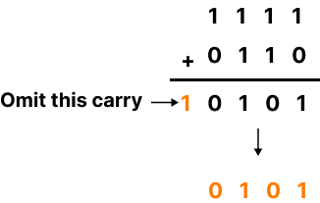

Subtract Using 2's Complement Method
To subtract a larger number from a smaller number using 2’s complement subtraction, the following steps are to be followed:
- Step 1: Determine the 2’s complement of the smaller number.
- Step 2: Add this to the larger number.
- Step 3: There is no carry in this case. The result is in 2’s complement form and is negative.
- Step 4: To get an answer in true form, take 2’s complement and change its sign.

Example: Subtract (1010)2 from (1000)2 using 2's complement.
Ans:
- Step 1: Find the 2's complement of (1010)2. It is (0110)2.
- Step 2: Add (0110)2 to (1000)2.
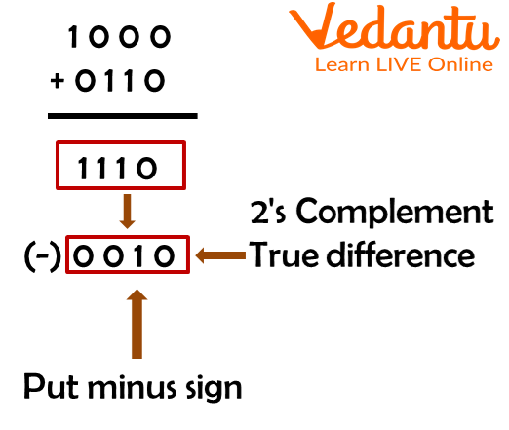

2’s complement
Step 3 and Step 4 have been explained in the above difference calculation.

Subtraction Using r's Complement:
Let's say you want to subtract the number 01010100 from 11100011. We can do this using 2 's complement by simply doing the subtraction using r's complement.

Steps to Find r's Complement:
To find r's complement, add 1 to the calculated (r−1) 's complement.
Here is an example:
Q. Find the 7's and 8's complement of the number (563)8
- Step 1: Identify the base (or) radix. Here r=8.
- Step 2: Since 7 is the largest digit in the number system, subtract each digit of the given number from 7, i.e. if it's a three-digit number, subtract the number from 777.
∴(214)8 is the 7's complement of a given number
- Step 3: To find r's complement, i.e. 8's complement, then add ' 1 ' to the result of 7 's complement number.
∴(215)8 is the 8 's complement of the given number.

Solved Examples
Q 1. 10110 - 11010
Ans: 11010 has a 2s complement of (00101+1) or 00110.
Add the 2's complement to the minuend (10110+00110) or 11100.
Now taking its complement;
The solution is (00011+1)= - (00100)
Q 2. 10110-01111
Ans: 01111's 2s complement is 10001.
The minuend plus the complement of two (10110-10001) equals 100111.
The response is 00111.
Q 3. 0100-11101
Ans: 11101's 2s complement is 00011
The minuend plus the complement of two (10100- 00011) equals 10111.
Since there is no carry here, the response is 01001.
Q 4. 110101 - 101001
Ans: 101001's complement in 2 is 010111
(110101-010111) Add the minuend and the 2's complement to get 1001100.
Carry, the result's leftmost bit is a 1 and is ignored.
The response is 001100.

Practice Questions
Q 1. 1001 - 0100
Ans: 0101
Q 2. 0100 - 1011
Ans: 1011
Q 3. 0110 - 0100
Ans: 0010
Q 4. 10110- 11101
Ans: 00111
Q 5. 110-101
Ans: 001

Summary
In conclusion, in this article, we went over two's complement subtraction. We've done an example problem to show you how it works and how it is performed on paper. The examples provided in this article are used for demonstration purposes only and thus do not necessarily model the types of problems you would encounter on a standardised test.
Instead of simply memorising the steps in this article, you should practice the problems. You can choose to use paper and pencil or use a calculator, 2 's complement subtraction calculator, or your fingers on your smartphone. Therefore, if you want to perform division (and thus subtraction) without using r's complement, you will need to learn how to use 2 's complement while performing division.

Method : 2's complement subtraction steps :
1. At first, find 2's complement of the B(subtrahend).
2. Then add it to the A(minuend).
3. If the final carry over of the sum is 1, then it is dropped and the result is positive.
4. If there is no carry over, then 2's complement of the sum is the final result and it is negative.

1. Find Subtraction of 110 and 101 using 2's complement method
Here A = 110, B = 101.
Find A - B = ? using 2's complement
First find 2's complement of B = 101
Note : 2's complement of a number is 1 added to it's 1's complement number.
1's complement of 101 is
 | 1 | 1 | 1
- | 1 | 0 | 1
 | 0 | 1 | 0
Now add 1 : 010 + 1 = 011
Now Add this 2's complement of B to A
1 | 1
 | 1 | 1 | 0
+ | 0 | 1 | 1
1 | 0 | 0 | 1
Hints : (Move mouse over the steps for detail calculation highlight)
The left most bit of the result is called carry and it is ignored.
So answer is 001
2. Find Subtraction of 10110 and 11101 using 2's complement method
Here A = 10110, B = 11101.
Find A - B = ? using 2's complement
First find 2's complement of B = 11101
Note : 2's complement of a number is 1 added to it's 1's complement number.1's complement of 11101 is
 | 1 | 1 | 1 | 1 | 1
- | 1 | 1 | 1 | 0 | 1
 | 0 | 0 | 0 | 1 | 0
Now add 1 : 00010 + 1 = 00011
Now Add this 2's complement of B to A
 |  | 1 | 1
 | 1 | 0 | 1 | 1 | 0
+ | 0 | 0 | 0 | 1 | 1
 | 1 | 1 | 0 | 0 | 1
Hints : (Move mouse over the steps for detail calculation highlight)
Here there is no carry, answer is - (2's complement of the sum obtained 11001)
Note : 2's complement of a number is 1 added to it's 1's complement number.
1's complement of 11001 is
 | 1 | 1 | 1 | 1 | 1
- | 1 | 1 | 0 | 0 | 1
 | 0 | 0 | 1 | 1 | 0
Now add 1 : 00110 + 1 = 00111
So answer is -00111

